Document Info

Title | Procedures for Creating and Importing Motion Guides
Document Type | Procedural
Division | Sands Digital Services
Department | Design
Authors | Charles Reid  George Van Der Volgen

Introduction

What is a Motion Guide, and it’s purpose?
A Motion Guide provides a detailed overview of the specific animations and motion features designed for each game.
Animations and motion elements that are not specific to one game but are intended for use across multiple games are classified as global elements. These will be documented separately in a comprehensive document covering all global assets for game-specific and category-specific animations.
Our developers, QA analysts, and other team members utilize these guides as a reference, as well as instructions on implementing the assets and animations correctly.
Each motion guide should answer the following questions about our animations:
- Have all assets and animations been given detailed descriptions?
- Has the method of delivery been described?
- Are all locations for assets documented?
  - Please list the file paths for these deliverables and avoid using hyperlinks
- Have all the different states for an animation been outlined?
  - Many of our animations have at least an active, and an inactive state. These states need to be listed along with the scenarios of when they should be triggered.
- Have all circumstances, keyframe data, or step-by-step instructions been accurately described, and depicted using graphics?

What is included in a Motion Guide?
These guides will cover all the details of the animations that trigger and occur throughout any of our games.
Global elements, however, are not covered in a game’s Motion Guide, unless there is an extremely specific reason to do so.

Global Elements and Animations
These guides will encompass all the specifics of animations that are triggered and take place across all our games.
However, global elements will not be included in a game's Motion Guide unless there is a rationale for doing so.

Formatting Guidelines

Standard Formatting

Document Creation – Blank Template
When first creating a document, please use the Blank Template located here as a foundation:
AreaX - Library - Design System - Documents\Library - Design System\Documentation\_Paligo - Motion Documentation Process\
This blank document has the basic formatting necessary for an uncomplicated import into Paligo, which can sometimes be temperamental.

Formatting
It is advisable to avoid cluttered tables, overly large margins and padding, text that wraps around, and similar elements. Simplicity is key, and this document contains all the essential elements needed to address most situations.
That said, please read the section discussing special circumstances where you might need to devise your own sub-format.
To emphasize importance, use bold, italics, or underlining. Text and background colors can also be effective, though background colors should only be used when essential. Avoid using highly contrasting colors; instead, opt for muted darks and pastel colors, which are easier on the eyes. Use these tools within reason to help our readers understand the information easier.

Structure and Flow
See “Structuring Guidelines” section for more information on how to break down the information logically.

Properties and Entries
Description: describe the animation with fine detail. Note anything that might need to be called out for the developers such as duration, triggers, special events, etc.
Actions / States: describe the various states of the animation, if necessary. In many cases this will just be a simple Active and Inactive state. If necessary, use the table included in the template to detail the various states.
Keyframe Info: Note any pertinent keyframe information here. This is usually applicable in situations where some part or all of an animation is dynamically driven. Use the included formatted list within the template to fill in this information.
Format: This is usually Spine, but can also be Hybridized, dynamic, etc.
Location: If a direct link is used, then it will be easily broken. Note the location of the parent folder, instead of the file itself. If the file gets renamed somehow or moved around within the folder, then it will still be locatable using this method. For example:
AreaX - Library - Design System - Documents\Library - Design System\Documentation\_Paligo - Motion Documentation Process\
For Image Entries: make sure to include a caption. Feel free to copy the caption from this example image below

An example image

Special Circumstances
Occasionally, a situation may call for a different format than is included, for instance this example of a wave effect created by triggering the animation on a delayed interval:
/// EXAMPLE ///
Wave Effect Delay Timing:
Seat 1: 0 frames
Seat 2: 5 frames / 166ms
Seat 3: 10 frames / 333ms
Seat 4: 15 frames / 499ms
Seat 5: 20 frames / 666ms
Seat 6: 25 frames / 833ms
Seat 7: 30 frames / 999ms

Just remember to keep things simple. Use bullets, simple styles like bold and italics, colors, underlines, and empty space to keep things easily understood and ingestible for both Paligo and our readers.

Structuring Guidelines

Global Elements
Global Elements should not be included in the game’s document. This information will be attached by dynamically linking to the necessary sections in Paligo.
These elements are broken down into game-centric and category-centric elements.
Global elements include:
- Card animations (eg: card flip)
- Chip animations
- Timer bars
- Action buttons
- Decision buttons
- Win animations
- Phase animations
- Sidebet animations
- Player balance animations
- Logo animations

Structural Elements
Animation entries in the *.WORD document should be structured by Game > phase or category > category (if necessary).
An example of a category subject might be “Character Animations”, and the reason this would work well is because the animations may occur throughout the entirety of the game.
Otherwise, animations that occur during a game phase should be included as “children” subjects of, for example, “Betting Phase Animations”, and then broken down further as necessary.
Occasionally, it may be necessary to break down the animations by Game, then phase or category.
For instance, a UK Bingo guide might cover that UK Bingo PvP has a slightly different ball animation than the Housebanked version. The guide would cover both versions of UK Bingo, but would need to separate the animations by game version, and then phase or category.

File types and saving

File Types
There are two file types used during the process of creating and importing our Motion Guides.
This process starts with a simple Word *.DOC, and ends with a *.PDF deliverable. This *.PDF is for viewing only. Editing is done via Paligo, or by editing the initial source *.DOC file which will be archived after the PDF is created.
Use a Blank Motion Guide Template Word Document from the Server:
AreaX - Library - Design System - Documents\Library - Design System\Documentation\_Paligo - Motion Documentation Process

Primary Location
Save the new Word / PDF document to the following Server directory using the included file name structure:
AreaX - Documents\GAME_NAME\Documentation\Motion_Guide-GAME_NAME.doc

What to do with old versions
Move old versions to the local z_Archive folder, and if there isn’t one you may create one.
AreaX - Documents\GAME_NAME\Documentation\z_Archive\Motion_Guide-GAME_NAME.doc

Paligo Brief Overview
Paligo breaks down documents into two major publication “file types”: articles, and topics.
An article is best described as a folder containing all the pages, or topics, of a publication. The article itself does not do anything but house the topics, or pages, within.
A topic is essentially a page, and contains a headline and other information.
For more information on how Paligo works, please visit their website to learn more or consult one of our relevant documents in the Content Manager.

Instructions for importing
NOTE: You will need Paligo Author privileges to follow these instructions. A Contributor level account will not allow you to view the full UI of their site, and greatly limits your functionality. This may be different at the time of reading, so please check their site first to verify.

Step 1
Use Blank Motion Guide Template from the Server:
AreaX - Library - Design System - Documents\Library - Design System\Documentation\_Paligo - Motion Documentation Process
Copy, and save the new Word document to the following Server directory using the included file name structure:
AreaX - Documents\GAME_NAME\Documentation\Motion_Guide-GAME_NAME.doc

Step 2
Once Document is filled in with all available information and reviewed, it is time to prepare our document for upload to Paligo.

For Paligo to ingest a file, it needs to be compressed in a *.zip file. It is unnecessary to do anything more than a simple compression, so if the machine asks for a compression ratio you may use the fastest.

On Windows platforms:
Right-click file and then locate the option for Send To >>> Compressed (zipped) folder

On Mac platforms:
Ctrl-click on file and locate Compress

Step 3
Once your document is zipped, it's time to login to Paligo
https://sands2.paligoapp.com/

Step 4
Once logged in, locate the following directory (Motion Guide Publications\_Topics Bin) in the Content Manager panel on the left. See reference below:
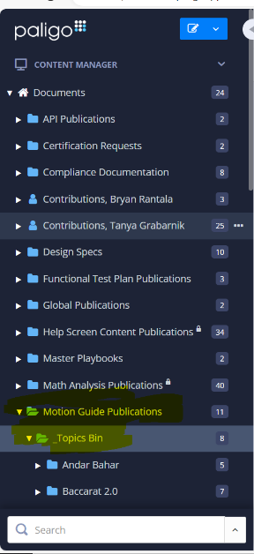

Step 5
Next, hover your mouse over the right-hand side of the panel where Motion Guide Publications folder is located and three dots should appear, then click to open the Context Menu. See image below:


In the now open Context Menu, locate and click Import Content, see image below:
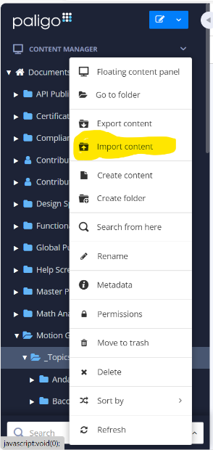

Step 6
You should now see a new window open that looks like this, asking which type of document you are importing:
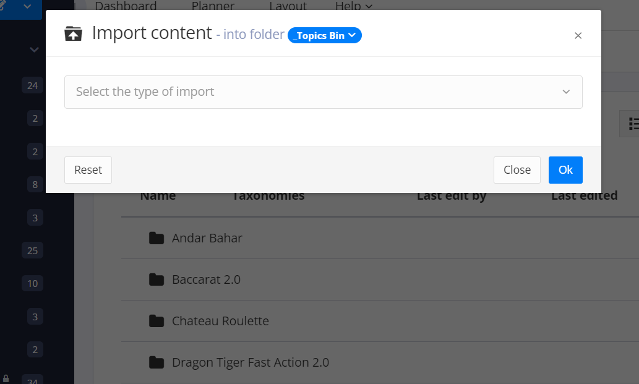

Locate Word (.docx) in the drop-down menu:
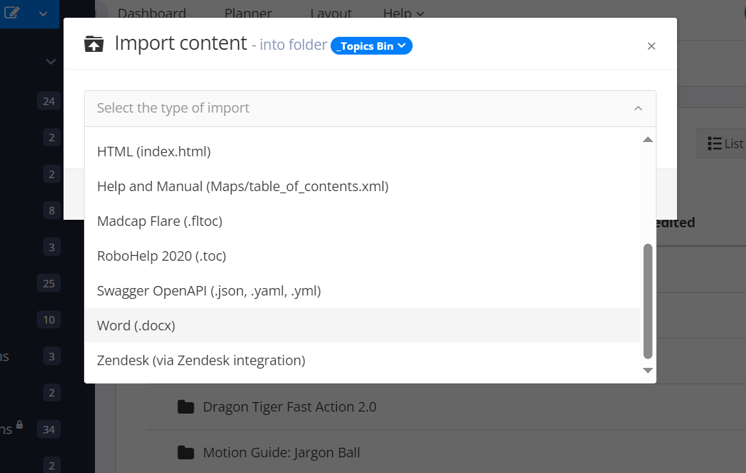

In the now expanded window, locate the blue Select File button, and locate your zipped document. For the rest of the settings, the defaults should be okay:
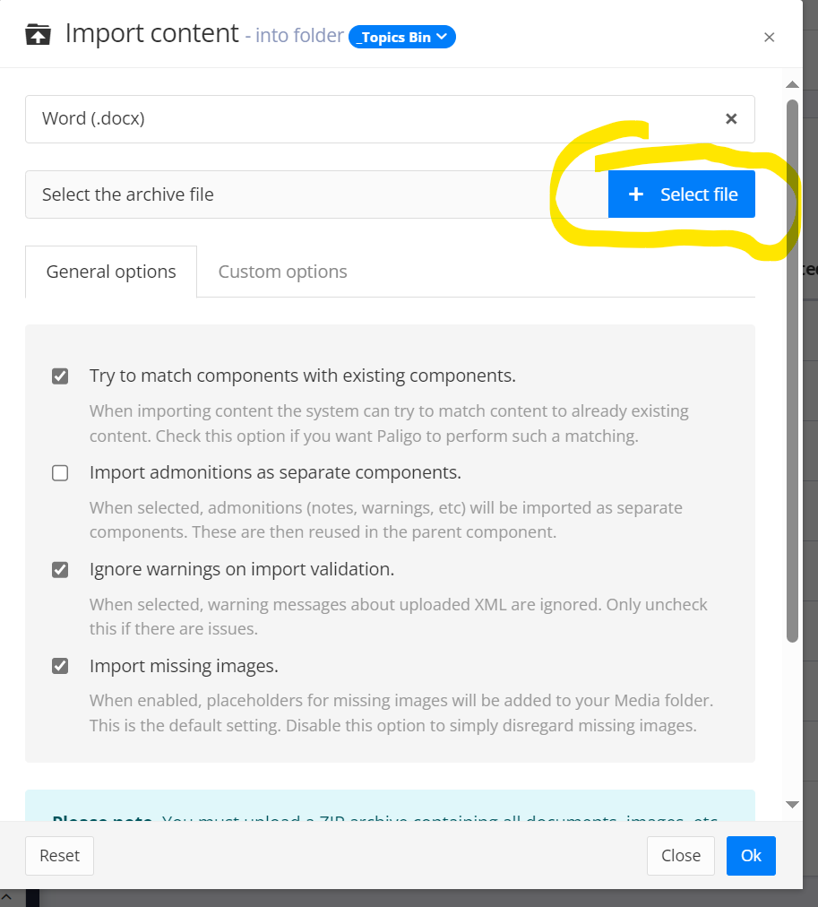

Click the OK button to initiate the upload. This will take a little time. Once completed, you should now see a confirmation, the page and directory will reload, and you should now see a new Topic in the corresponding folder.
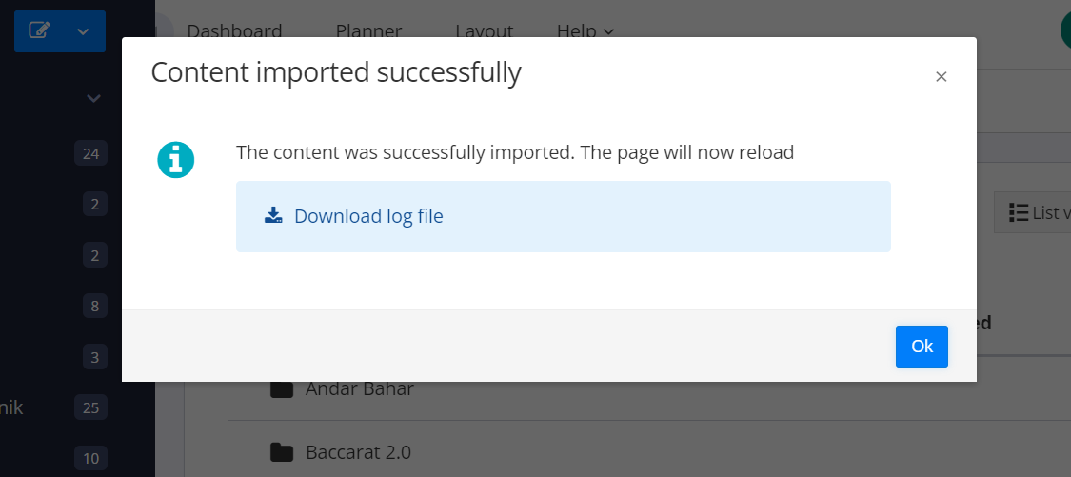

Step 7
For whatever reason, the default name for this new topic will be Article d5e1, and the folder structure will look like this including two sub-folders named Publication and Topics:
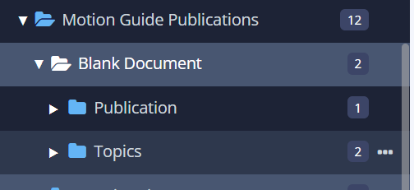
Expand both the Publication and Topics folders, and review that the document was imported correctly.

Step 8

Step 8.1
Once we have confirmed that the document was imported correctly, we will need to rename and relocate two items:
- Rename the Article in the Publication folder from “Article d5e1” to “Motion Guide (CODE) – GAME NAME”.
Then drag this Article (Not the Publication Folder) to the main Motion Guide Publications folder along with the others. See image below.
The CODE is usually something like TG88 or GS01. If you don’t know the code, or one hasn’t been created yet then you can use XXXX until one is established.
- Rename the Topics Folder to “(CODE)_GAME NAME”. Then drag this folder into the _Topics Bin. See image below for a visual reference:

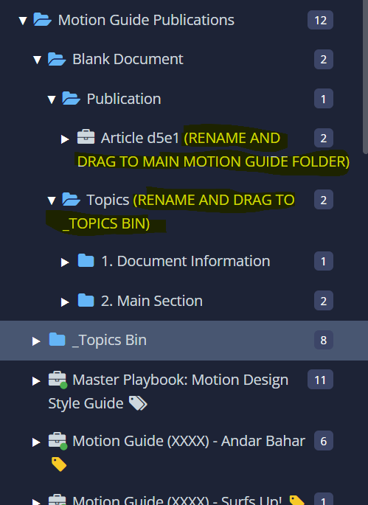

Step 8.2
Next, we will attach any necessary “topics” / sections from outside the article, specifically from the Global Motion Guide. These created links will be dynamically linked, and thus reflect any updates made to the source topic.
In order to copy and paste a dynamic link to another article or document on Paligo:
- Locate and click on the target Article to open the “Structure View”
- Hold SHIFT and then click-drag that item to the desired location in the “Structure” window. View the example below for a visual reference.
The newly created item will have an icon that looks like a document with a two arrows following each other, and have text next to it that states “Structure reuse”. See image below. If you need to dynamically link an entire article, follow the same steps, but note that the icon will be different and look like a “recycle” symbol. See image below:
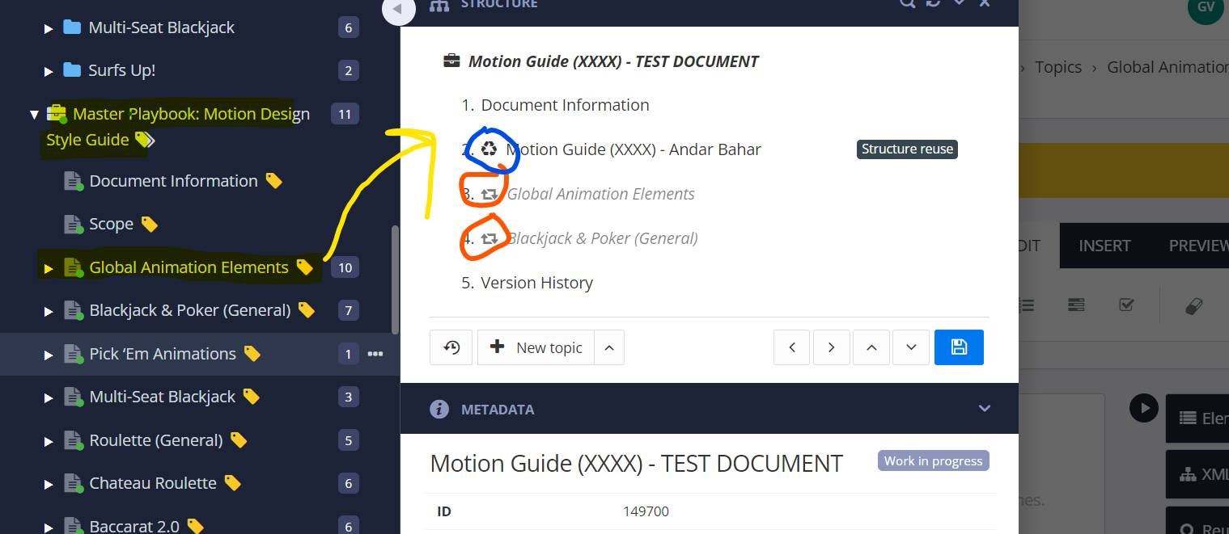

Step 9
Once step 8 is complete, we can now export a PDF to be placed in the Handoff > Animation folder for the corresponding game.

To start this process, open the Context Menu for the games’ Article (the white briefcase icon) being exported, and click Publish:
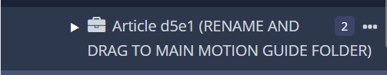
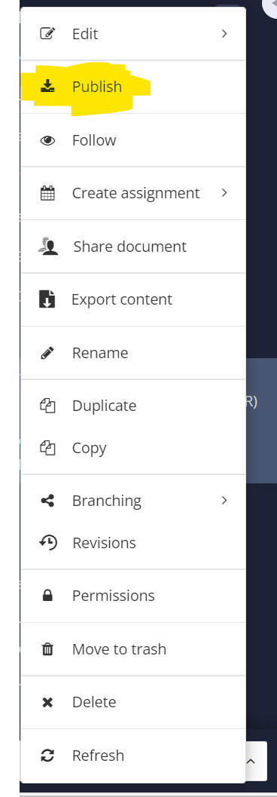

Step 10
In the Publish Document dialog box that opens, click PDF, and leave the settings on their defaults. You can change the filename in the location in yellow in the following screenshot:
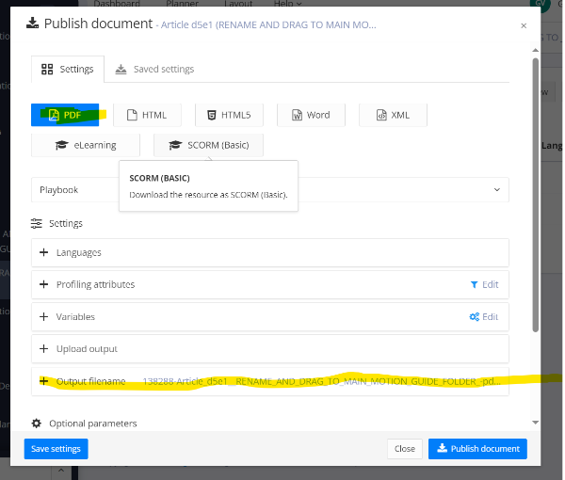
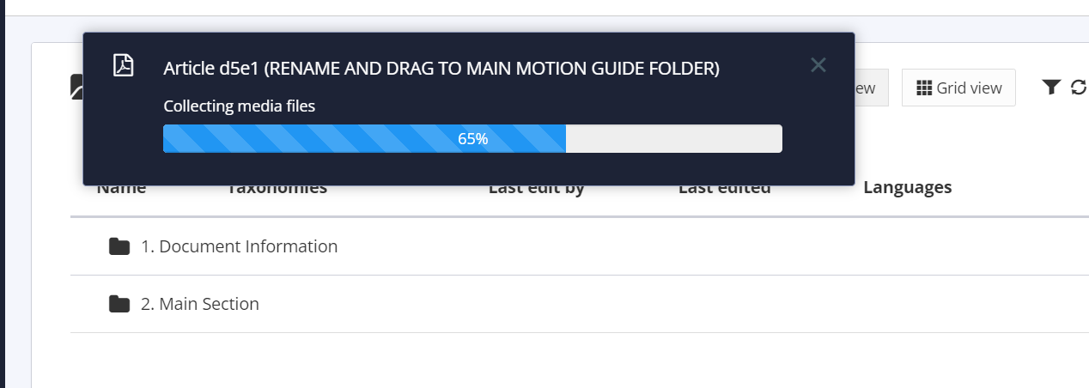

Click Publish Document and the file will begin processing, followed by downloading through your browser

Step 11
Once the download is complete, unzip the folder and locate your PDF nested within, it may be a couple of folders deep.

Step 12
Move this PDF to the corresponding games’ Handoff > Animation folder. Make sure to archive any old versions to the local z_Archive folder. If there is no Archive folder, please feel free to create one.

After Importing
After importing to Paligo, you have a couple options as to how you can make edits.
For small edits, try editing directly in Paligo first and then exporting a new *.PDF, but be sure to reflect those changes in the *.WORD.
It’s usually much faster and simpler to edit the source Word document, and then repeat all steps here to import a fresh copy into Paligo.
Make sure to archive or delete the *.PDF and delete the associated Articles on Paligo, so there aren’t errant copies floating around.

Delivery and Final Steps
The *.PDF is our deliverable, and this should be saved in the appropriate Handoff folder.
Keep the source *.WORD document available in the local z_Archive folder, so that you can edit it later.
All edits made on Paligo should be reflected in the *.WORD document also to avoid discrepancies. This is why it’s usually a good idea to keep the *.WORD document handy, as you will likely need to edit and reimport several times.

