Document Information
Title | Global Elements for Motion
Document Type | Motion Guide
Division | Sands Digital Services
Department | Design
Authors | Charles Reid  George Van Der Volgen

Global Animation Elements

Global animations include elements reused across all or some of our games. Examples include:
- Timer bar
- Chip selectors
- Chips
- Buttons

Asset location: Production > _Global > HandOff >

Standard animations include elements that are frequently included in our games but are customized for each game, such as:
- Win screens
- Phase changes (Place Your Bets, Bets Closed, Pick Your Cards, etc.)
- Betting and chip FX
- Logo animations

Asset location: Production > the specific game folder > HandOff > Animation_assets

Formats

Most of the animations for our games are exported via Esoteric Spine 2D.

All Spine animations are exported at 30FPS.

For game logos on the loading screens, we use an Adobe After Effects plugin (Bodymovin or Lottie) to export vectorized animations as .json files.

Common animation styles

- Scale up/down – the preferred transition style for most situations in our games is a rapid scale up from 0% to 100% with a slight overshoot to around 110% before returning to 100% scale. The overshoot should ease in and out so that the element feels smooth as it comes to rest.
Durations for small elements should last approximately 300ms, with larger elements taking slightly longer depending on their size.
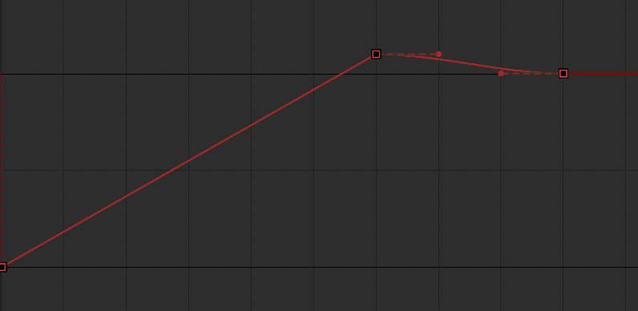
Scale up with overshoot

- Wipe in/out – Sometimes a wipe transition is best, particularly for larger elements such as banners. These are done by animating a mask. The element should transition on from left to right and exit the screen in the opposite direction.
Most durations should last approximately 300ms.

- Fade in/out – Fades are used in some situations where too many other transition type are already being used. Too many of the same transition style at the same time can feel chaotic and disorderly. A simple quick fade can be used to have elements enter/leave the screen in a subtle way. Fades are particularly useful for situations in which we do not know how long the element will remain on the screen and we want the developers to be in control of when the element leaves the screen.
Most durations should last approximately 3sec/3000ms.

Avoid “POPS”

Whenever possible, elements should fade on/off quickly rather than suddenly appearing or disappearing.

When things pop on or off suddenly the eye will catch this, and it will feel like a mistake.

Logo Animation, Game Loading Screen

The loading screens for our games are placed according to a standard format.
- Game logos are centered
- Loading bar is placed below the logo
- Background visual is usually a radial color gradient or a supplied image

While the game is loading, we show a quick animation of the game’s logo entering the screen. The logo has a looping element that continues to play until the game is successfully loaded.

The background of this screen fades out about 1000ms or so before loading finishes, revealing blurred footage of the game (the loading bar should be approx. ¾ full when this happens).

All elements (logo, loading bar, etc.) should fade out rather than instantly disappear.

Duration: The logo enter animation is typically 2sec long
Asset location: Lottie/BodyMovin .json file

Element, Timer Bar

The timer bar is a global element commonly found in our live dealer table games.

The timer is used during various phases of a game where there are strict time limits, such as placing bets.

Timer bar elements can be found in the global production folder at Timer.


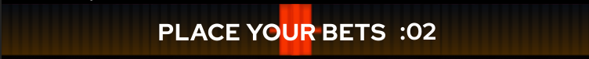
An example of the timer bar

Dynamic Segment Units

The timer is divided into various segments that correspond to the number of seconds to the left and right of center.

The timer segments are dynamic, meaning we can adjust the amount of time each segment represents.
- Usually, 1 segment on either end of the timer is equal to one second.
- If the timer is very long (over 30sec) the segments may change to be 2sec each.
- If the timer is very short (under 5sec) then the segments may change to be .5 sec each.
- The timer is designed so that one segment will be left before the timer reaches 00.

Animation

- The timer bar seconds total should always be displayed with at least 2 digits and include a colon (:00).
- The timer segments will change color as the timer progresses down to 00. The colors typically start at green and then change to yellow and finally red. The background color is typically a blue/black gradient. These colors may be adjusted for specific games.
- When the timer bar starts, show the timer segments fading on quickly before they start to tick down (avoid a “pop” where the timer segments instantly appear.).
- As the seconds expire, each timer segment will animate off with a vertical gradient shift to the center.
- When the timer hits 00, there is a red/white flash as it expires.

Messaging

The timer bar is used for various game-specific messaging even when the timer bar is inactive.

Buttons

Action buttons are used globally on card-centric live dealer games. These buttons are delivered via Spine. The button bevel color is dynamically changed to match the color style of the game via skins in Spine.

Note: In some cases, the animated states may be omitted and static button states may be used instead. This decision is made on a game-by-game basis, taking into consideration factors such as number of buttons, button layout, layouts on certain devices, etc

Button States

- Normal (static)
- Hover (animated - only on desktop)
- Press (animated)
- Disabled (static)

Action Buttons

Action buttons are any button where the user is taking action to do something. These buttons include, but are not limited to:


An example of some action buttons

- Autoplay
- Cancel
- Cashier
- Chat
- Double bet
- Help
- Re-bet
- Switch table view
- Tip
- Undo
- Volume off/on

Decision Buttons

Decision buttons are considered to be any button where the user must make a decision, usually while a clock is ticking.

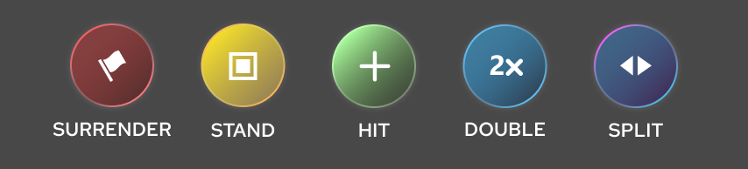
An example of some decision buttons

- Accept
- Surrender / Quit
- 2X / Double Down
- Hit
- Stand
- Split

Animations, Card Flip
Description: This effect is triggered whenever a card is revealed.
Format: Spine
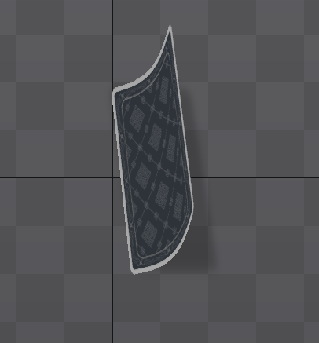
An example of a card flip animation

Animations, Chip Placement FX

Chip placement effect animations occur when placing any chip(s) on a bet area.

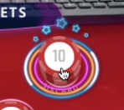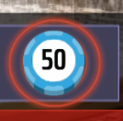
An example of effects occurring during chip placement

Common Chip Placement FX Animations

- Bet-placed (25 frames or 833ms): FX animation for basic placing of chips
- Bet-placed-double (25 frames or 833ms): This effect is a bit more exciting, and used in situations when chips are automatically placed such as the 2X or Call buttons.

Animations, Winning and Losing Chips

Description: Once the game result is determined, players are accordingly awarded based on how much they bet and how the paytable is structured. These winning chips stacks are meant to mimic the experience of real-world casinos where dealers will slide additional chip stacks next to the original winning bets on the table.

Our winning chip animations are very similar across our games. All card games should behave as described below.

Roulette games work differently as the winning chips are not stacked next to the original bet, but on top of the original bet.

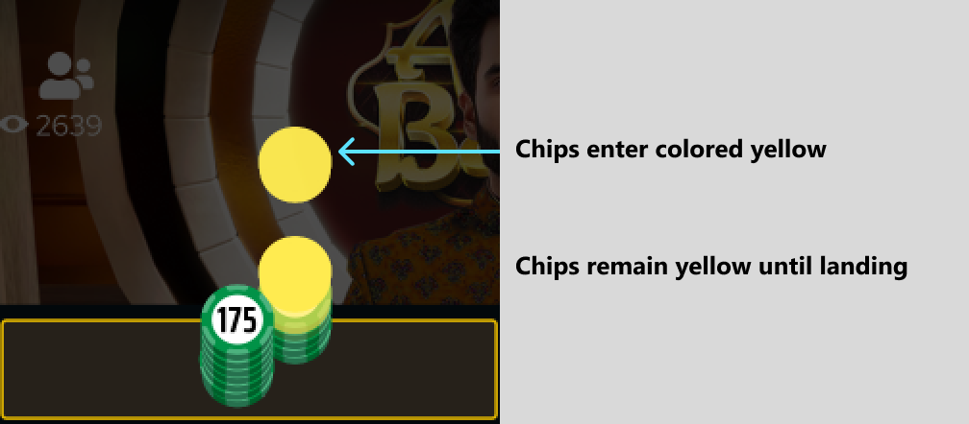
An example of winning chips entering

After the winning bet has been decided:

Each winning chip enters tinted opaque yellow, dropping downward just behind and to the right of the original bet, as illustrated above.

As each chip lands, the yellow tint fades off quickly.

About 300ms – 500ms after the first chip lands, the losing chips should: exit away from the player (toward the dealer), slightly scaling down and fading out as they do. See illustration below.

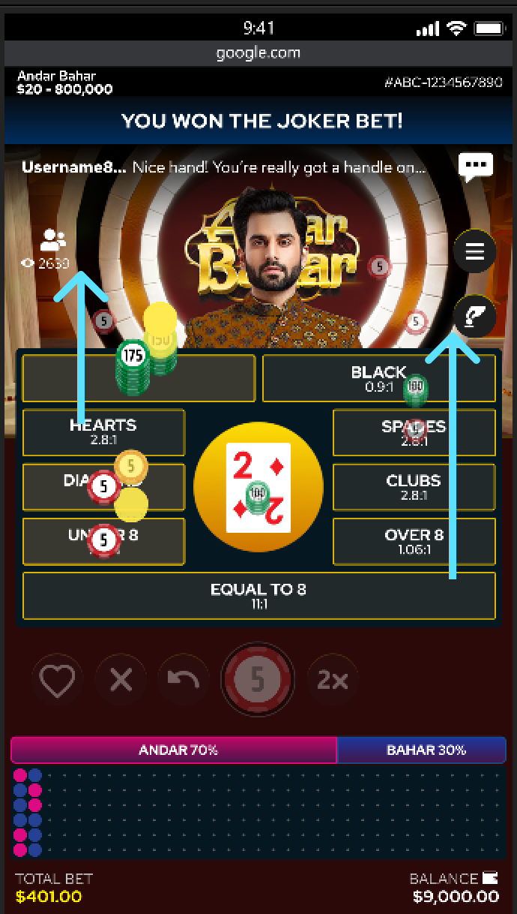
An example of the losing chips leaving the table

Promptly, once all, or nearly all, chips have entered, the sparkle animation starts on the new and original winning chip stacks.

The sparkles should continue to loop while the chips remain on the board.

The winning chips will then exit, scaling up as they move closer to the player, then fading away quickly as they approach the bottom of the screen. See image below.

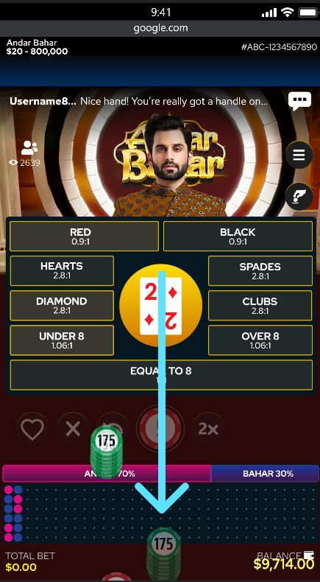
An example of the winning chips leaving the table

The movement should start slowly with a strong ease-in so that they begin to speed up as they continue.

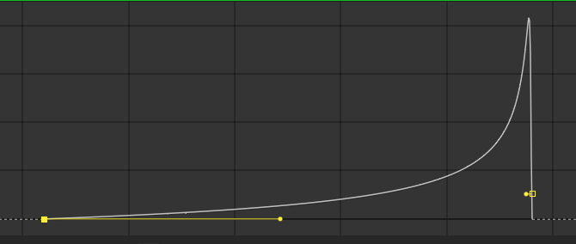
An example of the animation curve for the winning chips exiting

The motion should feel like a dealer sliding a stack of chips across a felt table.

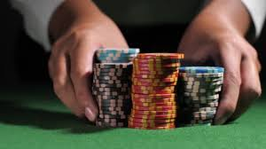
An illustrated example referencing how the chips should feel like a dealer is sliding them away

Once the chips have moved off the board the table should immediately transition back to the default state for the next round.

Animations, Phase

Phase animations are used to announce major phases of the game like “Place Your Bets” and “Bets Closed”. However, there are occasions when additional phases are necessary.

Common Phase Animations
- Place Your Bets (65 frames or 2165ms)
- Bets Closed (65 frames or 2165ms)

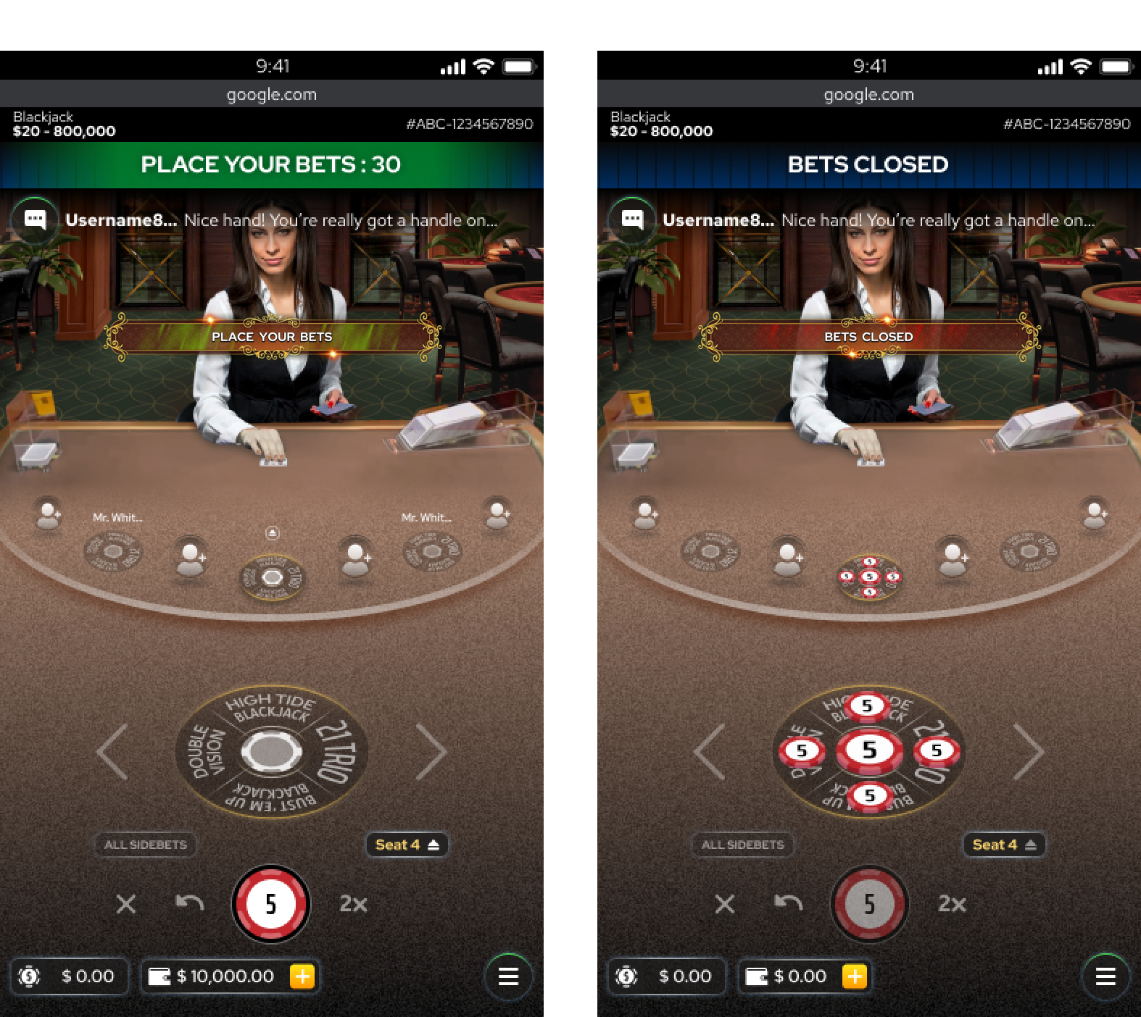
An example of a phase animation

Animations, Win

Win animations are shown when the player wins at the end of a round of play. There are four typical variations of these win animations (also referred to as “win rankings). The animations for each is progressively more impressive and should be associated with a higher value win.
Currently, the placement of these animations is centered on the dealer video to keep the game object zone clear.

Common Win Animations

- You Win (75 frames or 2498ms)
- Big Win (90 frames or 2997ms)
- Huge Win (105 frames or 3497ms)
- Ultimate Win (120 frames or 3996ms)

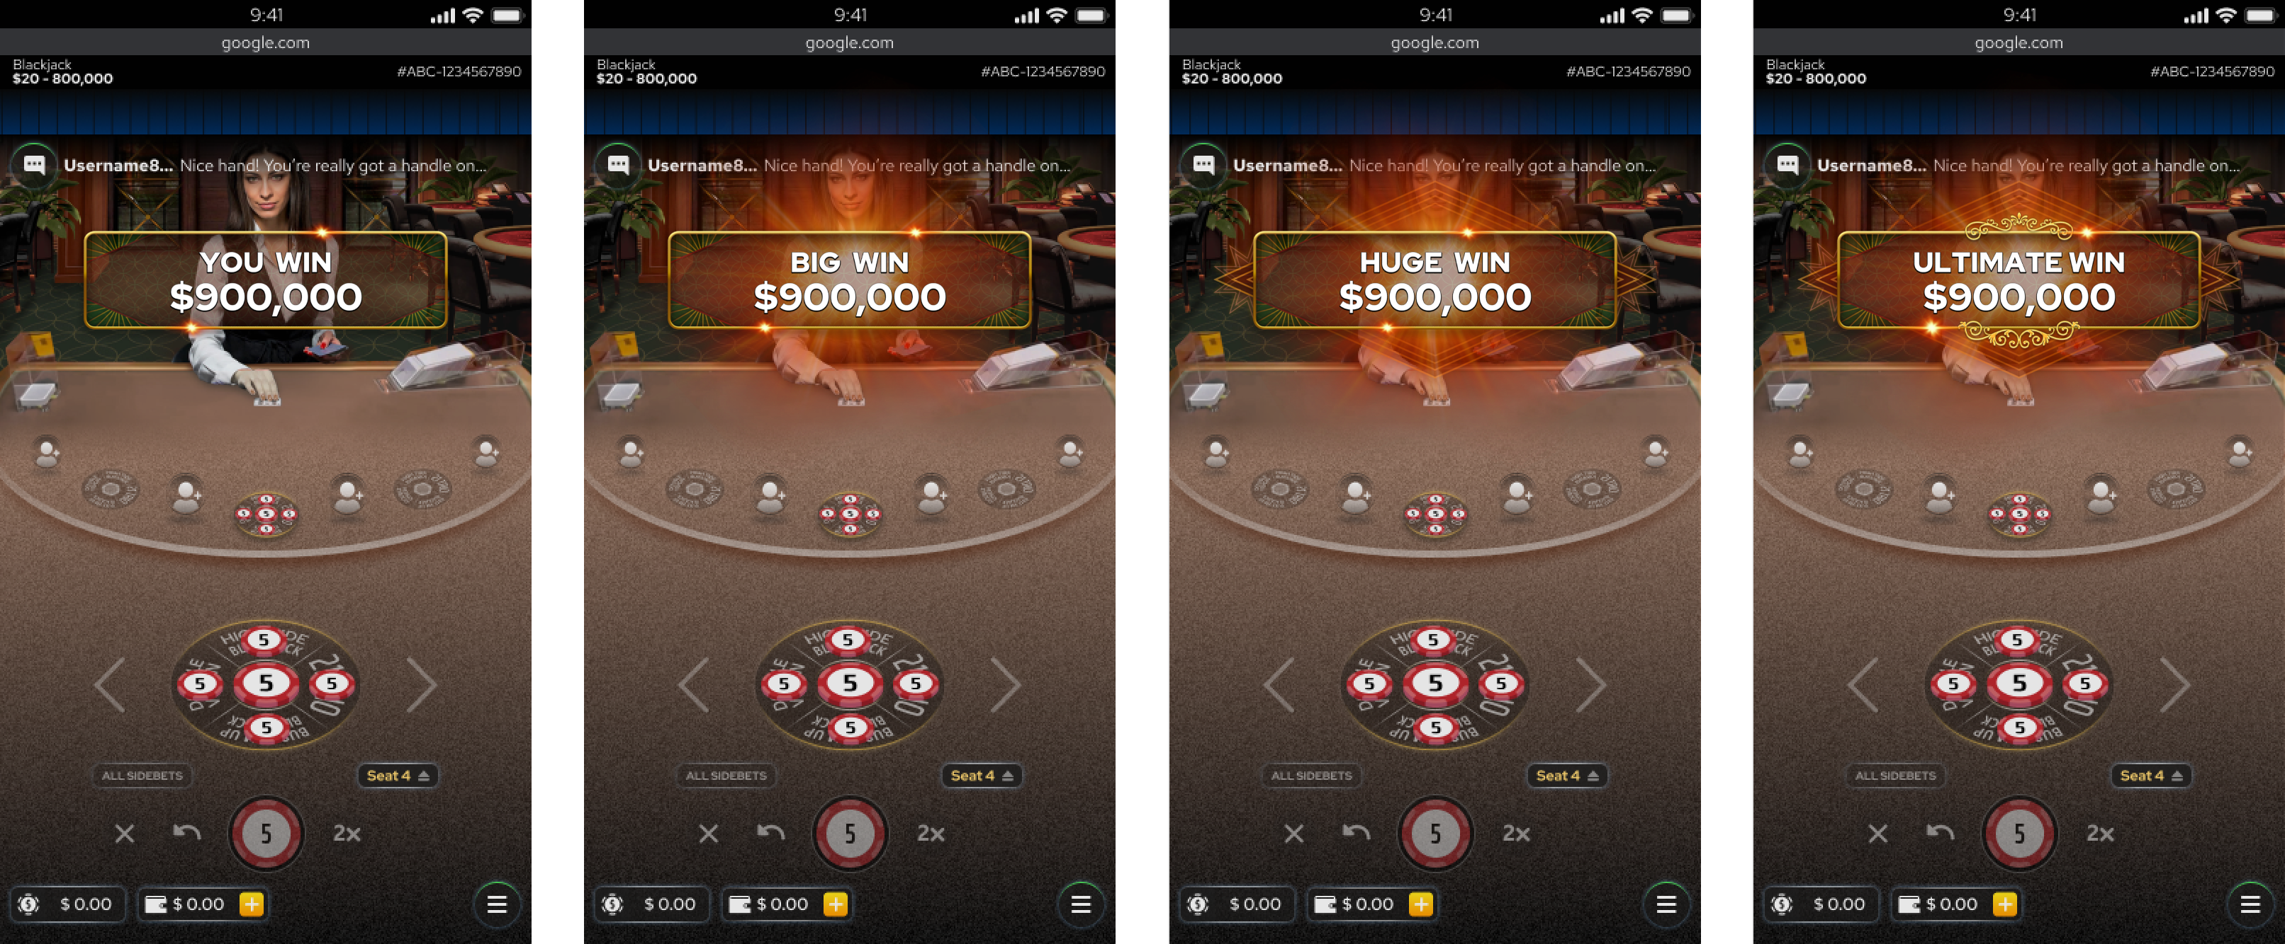
An example of a win screen animation

Animations, Wallet Balance Rollup

Description: Each time the player’s wallet total increases a special animation should play. This animation should ONLY play when the balance increases (not decreases). This animation only plays on the wallet field.
The total will change to a bold/gold style and do a wave animation while the number rolls up.

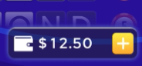
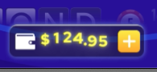
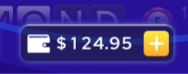
An example of the wallet animation

Further details can be found in the handoff folder for this feature.

Asset location: Production > _Global > HandOff > Balance_RollUp_Animation

Game Resolution Overview

After the result of a game is determined, the game resolution phase begins. This includes notifying the player of all outcomes related to their bet(s).

STEP 1: Any additional chips resulting from winning bets are neatly placed on the table next to the corresponding winning wagers.

STEP 2: Losing bets are removed from the table. This occurs just after the start of the winning chips animating in. Ideally, we’d have the winning chips enter, then a half second later start exiting the losing chips.

STEP 3: The win animations play which show the player’s total winnings for this round (SPINE).

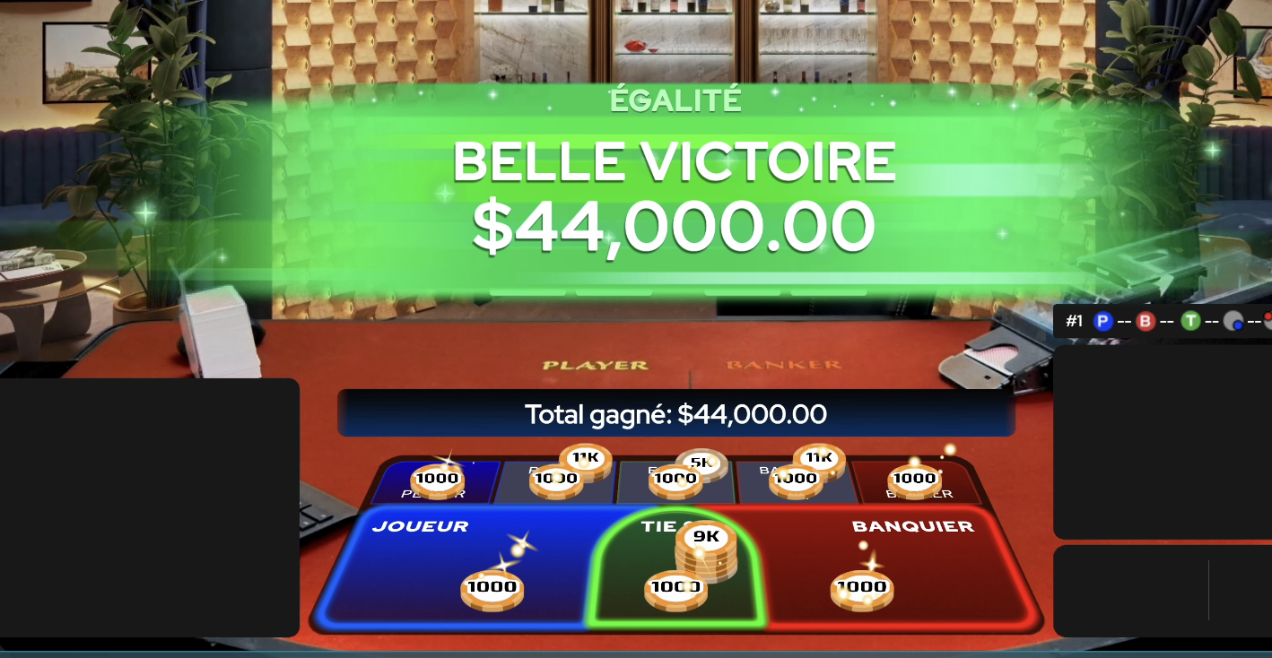
An example of a winning round

STEP 5: Winning chips are moved off the table as the win animation ends, just before.

STEP 6: The table transitions to accept new bets for the next round.

Roulette - Global

Displaying Results and Win Messaging
Description: All roulette games share a similar format in how they display the results of each game. This occurs via the “Wheel Stop Banner”, which displays the winning number in the center with the adjacent numbers flanking each side.
This banner shows at the end of every game regardless of whether the player has won, or not.
If the player has won that round, then additional win messaging is displayed on top, or below the wheel stop banner. This layer order varies per game/design.
The banner and win messaging appear centered over the video feed.

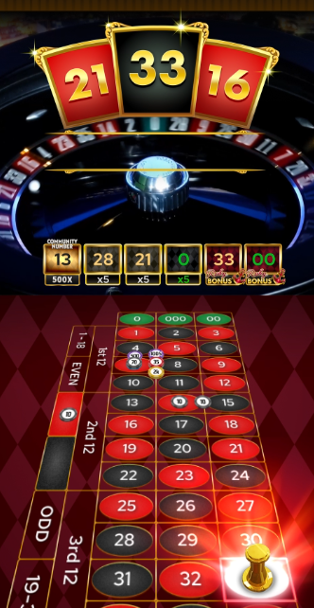
An example of a winning round and the “wheelstop” graphic

Dolly Animations
Description: The dolly (or “roulette marker”) is a small object that resembles a chess pawn. When the winning number is revealed the dolly animates in at the far end of the board, and then moves forward until it is over top of the winning number. The dolly then descends, landing on the winning number.

Necessary states for Dolly (roulette marker):
- fly (marker appears, animation)
- landing (animation)
- landed (one-frame animation)
- hide (marker disappears, animation)
- idle (one-frame "empty" animation)

The dolly will be reskinned for each unique roulette game.

There are several different effects that play once the dolly lands on the winning space.
- Primary win – this effect plays once at the base of the dolly on the winning number.
- Secondary win – this effect plays once at the bases of chip stacks that won, not the winning number. These effects are similar to the primary win effect, but a lot more subtle.

Table effects
Description: In some roulette games there are special effects appearing around the edge or in the middle of the table during specific game events (e.g., when the bet phase begins or ends). Various highlights and other animations may also appear on the board itself and corresponding bet areas. These animations vary per game, but most games have at least one effect.
Table effects may include:
- Border highlights around bet areas, glows emanating from bet areas, multiplier numbers or other icons, flashes/glows around the perimeter of the table, etc.

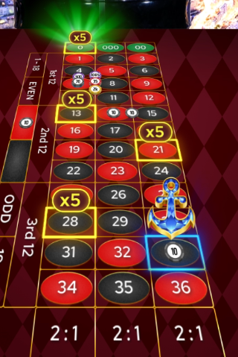
An example of highlight treatments and board effects during a bonus event

Blackjack - Global

General

Insurance and Dealer Bust Modal
Description: These occur during resolutions and act similarly to Phase animations in that they will sit above most of the other elements, drawing attention to a certain outcome.
The insurance animation / will last for an indeterminate amount of time but would theoretically end when either the player makes a choice, or a timer runs out.

Splits Flow Animation Notes
Description: To achieve the slide-behind effect:
1. When card(s) X starts to move, a clone or clones appear directly underneath and below the current tab
2. Both card(s) X and the clone move on the same path towards the destination
3. As the card(s) and clone(s) reach the boundary / edge of the tab, the top card(s) fade away

Note: This effect only occurs after the player has accrued 3+ hands from splitting.

Pick ‘Em Animations
The Pick ‘Em feature allows players to select their own starting hand from a pool of face down cards. This sense of choice creates a more engaging experience. The Pick ‘Em feature is composed of a set of global designs and animations that will be restyled (colors, fonts) for each Pick ‘Em titled game.
The Pick ‘Em interface consists of a series of incrementally numbered boxes with a smaller box below containing a percentage indicator. Both elements act as a button for the player to interact with.
There are various static and animated states for these.

Common Animation States
The pick em animations are built into a single Spine file that can be reskinned for different games.
- Normal-loop – the normal state has a looping pulse/flash animation that should continue to play until the required number of choices have been selected. This looping animation is meant to cue the player that a choice needs to be made.
- Enter – the button scales from 0 to 100 when first appearing. These buttons should play their “Enter” animation in a staggered sequence, one after the other. This takes half a second.
- Deactivate - for when other choices have been confirmed
- Selected-loop – this is a looping animation where an outline of the selected number will scale up within the main box frame. This will happen over and over again while this state is active. The outline of the font is a PNG that should be dynamically swapped into the empty slot.
- Confirmed – this state shows when the player has confirmed their selections.
(Note: The Spine file includes static versions of these animations as well incase those are useful)
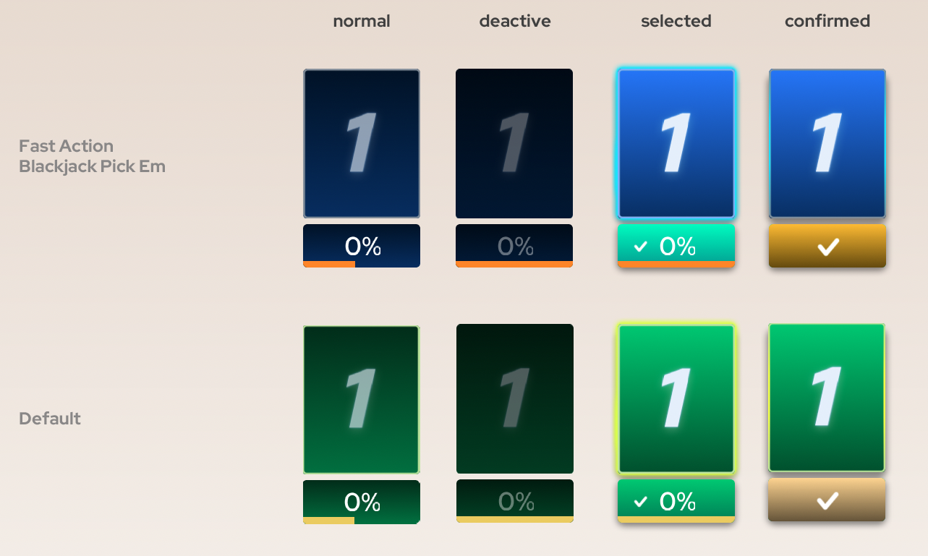
An example of various stylings of a picker box

